<Logo of the Company/Group might be here. Use Cairo University logo>

<Company/Group name>

<Project Name>
Software Requirements Specification (SRS)
Version: <X.Y>
<CM Identifier: Configuration Management Identifier that can be used to uniquely reference the document among other documents and you should rename the file name with this identifier >

[Note: The Software Requirements Specification (SRS) captures the complete software requirements for the system, or a portion of the system. Following is a typical SRS outline for a project using use-case modeling. This artifact consists of a package containing use cases of the use-case model and applicable Supplementary Specifications and other supporting information. In addition to the requirements specifications, market survey, feasibility study and high level plan will be added to the document]
Revision History

Sl. No. | Prepared/  Modified by | E-mail | Version | Date | Approved by | Descriptions/  Remarks
1. | <Name(s) of the author(s)> | <e-mail> | <x.y> | <Mmm. dd, yyyy> | <Name of the approving authority> | <The action performed on the document. Include a link to the modified part>

Distribution list
Name | E-mail | Notes
<List all persons/departments to which this document will be distributed> |  | <Any useful remarks like “reply needed”, “for approval”, etc…>

Table of Contents
1. Introduction 5
1.1 Purpose 5
1.2 Scope 5
1.3 References 5
1.4 Overview 5
2. Market Survey 5
2.1 <Project Name> 5
2.1.1 Project Description 5
2.1.2 Functional Specifications 6
2.1.3 Non-Functional Specifications 6
2.1.4 Limitations 6
2.2 <Project Name> 6
2.3 <Project Name> 6
2.4 Summary 6
2.4.1 Functional Specifications 6
2.4.2 Non-Functional Specifications 6
2.4.3 Limitations 7
3. Cost Estimate 7
4. Feasibility Study 7
5. Requirements Specifications 7
5.1 User Requirements (User Stories) 7
5.1.1 <Requirement Description and priority> 8
5.1.2 <Requirement Description and priority> 8
5.2 System Requirements (Use Cases) 8
5.2.1 <Use Case Description> 8
5.2.2 <Use Case Description> 8
5.2.3 <Use Case Description> 8
5.3 Non-functional Requirements 8
5.3.1 <Requirement Description and the user stories ID that this requirement is addressing> 9
5.3.2 <Requirement Description> 9
6. High level plan 9
6.1 User Stories Time Plan 9
6.2 Staffing 9
7. Supporting Information 9

Software Requirements Specification

Introduction
Easy fit , is a website which facilitate the diet process and help people to have a healthier life . In this document we will discuss our main functionalities, how different our project is from other competitors, the feasibility Study of our project and the cost estimate of the project.

Purpose
The project’s main purpose is to help everybody have a healthier life . So in this system we will try to help them reach that by providing them with some features (the functional requirements) that make that goal easier to reach , also we will try to make the system user friendly and secured (nonfunctional requirements) .

Scope
The scope of the project is to provide the users with some features that will help them
build their bodies in a right way and keep fit, know their ideal weight , the system will also provide them with some exercises for different body shapes in addition to a collection of tips about healthy food and habits that will help users keep their bodies fit and slim especially for those who want to lose weight.

References
Links for competitors sites :

[This subsection should provide a complete list of all documents referenced elsewhere in the SRS. Each document should be identified by title, report number (if applicable), date, and publishing organization. Specify the sources from which the references can be obtained. This information may be provided by reference to an appendix or to another document.]

https://css-tricks.com/web-developer-economics-hardware-costs/
http://executionists.com/cost-to-build-websites-2014/
http://www.payscale.com/research/US/Job=Software_Development_Engineer,_Test_(SDET)/Salary

Overview
In this SRS ,after the introduction we will talk about the market survey for similar projects , we will describe the features they offers to the user ,their functional and nonfunctional requirements . Then we will make the feasibility study and then we will describe the functional and nonfunctional requirements of our project stating
user requirements (user stories) and System requirements (use cases).At the End, we will provide some extra information that shows traceability and dependability between user requirements to facilitate design, implementation and testing process.

Market Survey
<Perform a search over the Internet for similar projects. If you know someone in the market who has a similar project, go and interview him/her. Now is a good time to give up being shy! For each similar project, give a separate section as follows>

Choose my plate http://www.choosemyplate.gov/
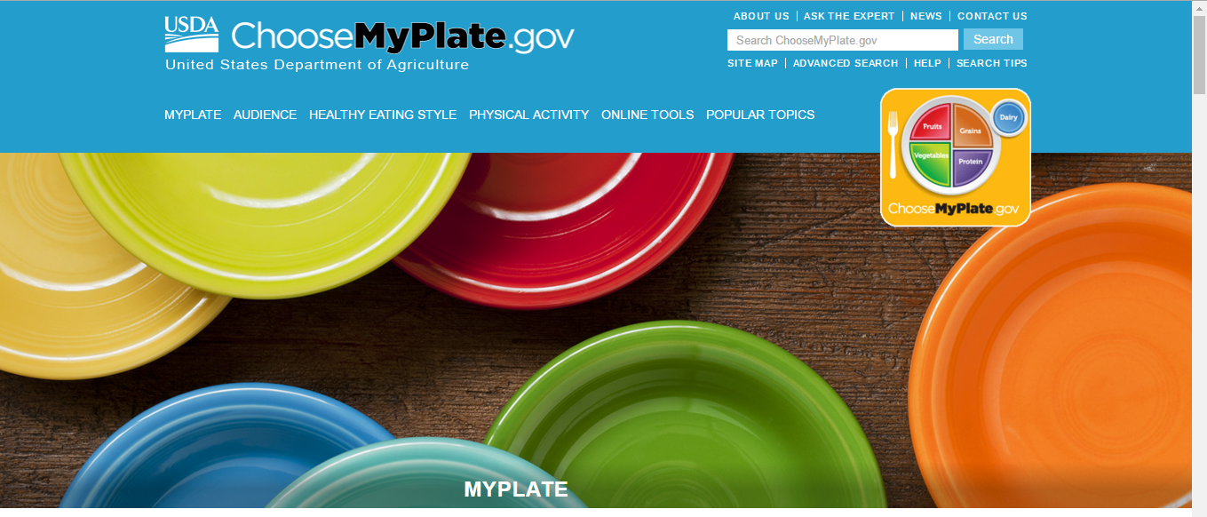

Project Description
My Plate is a reminder to find your healthy eating style and build it throughout your lifetime. Everything you eat and drink matters. The right mix can help you be healthier now and in the future. This means:
- Focus on variety, amount, and nutrition.
- Choose foods and beverages with less saturated fat, sodium, and added sugars.
- Start with small changes to build healthier eating styles.
- Support healthy eating for everyone.
<Give a brief description for the project. Give information about the organization in which the system is deployed, the developing company, etc.>

Functional Specifications
- Nutrition functions
- Search for Information about different types of food such as fruits , vegetables ,grains , proteins and oils.
- Search for Nutrients and health benefits.
- Food gallery (contains pictures of food)

- Physical activities
- Providing information about how to burn fat using exercise .
- Providing tips for increasing physical activities
.
- Weight function
- Provide pregnancy weight calculator that calculate how many pounds ypu should gain during your pregnancy.

Non-Functional Specifications
- the interface is user friendly.
- Good response in searching.
- Information is classified by type of audience (adult , childrens , student…)

Limitations
- It mainly provides information about healthy food but it doesn’t have certain diets.
- There is no interaction with the user.

<Project Name>

<Project Name>

Summary
<This should summarize the previous section. You should classify the specifications above into categories and specify the essential and non-essential specifications>

Functional Specifications
<This should provide a structured listing of the functional specification in similar projects grouped into categories. Write two sections for essential and non-essential specifications>

Essential Specifications

Non-Essential Specifications

Non-Functional Specifications
< This should provide a structured listing of the non-functional specification in similar projects grouped into categories. Write two sections for essential and non-essential specifications>

Essential Specifications

Non-Essential Specifications

Limitations
<You should summarize the limitations present in these projects and analyze their reasons. Discuss how your project may overcome these limitations>

Cost Estimate

Item | Estimated Cost
Item | US Dollars | L.E.
1. Development Cost
1.1. Test Software Development Engineers | $94K /year | 836.6K L.E/year
1.2 Software Systems Engineer | $111K/year | 987.9K L.E/year
1.3 Software Developer | $ 120K/year | 1068K L.E/year
1.4 Database Administrator | $ 126K/year | 1121.4KL.E/year
1.5 Database Developer | $90K/year | 801K L.E/year
Total | $541K/year | 4814.9KL.E/year
2. Deployment Cost
1.1 Domain Name | $15/year | 133.5 L.E/year
1.2 Hosting | 80$/year | 712 L.E/year
1.3 Security monitoring | $200 / year. | 1780 L.E/year
Total | $295/year | 2625.5 L.E/year
Total Estimated Cost | $541,295/year | 4,817,525.5 L.E/year
Table 2: Cost Estimate

<Provide different tables for different alternative solutions. At this phase we only require a broad estimate, not too accurate since you have not specified every requirements, yet search over the web for reasonable cost estimates>

Feasibility Study

Overweight and obesity are defined as abnormal or excessive fat accumulation that presents risk factors for cardiovascular diseases and diabetes and have major role in sudden premature deaths.

According to statistics of SPI [Social Progress Index] Egypt is the 4th among the most 15 Countries in the world that suffers from obesity with obesity rate 34.6%

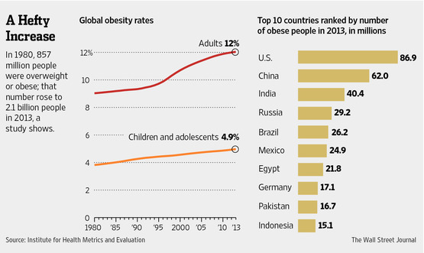

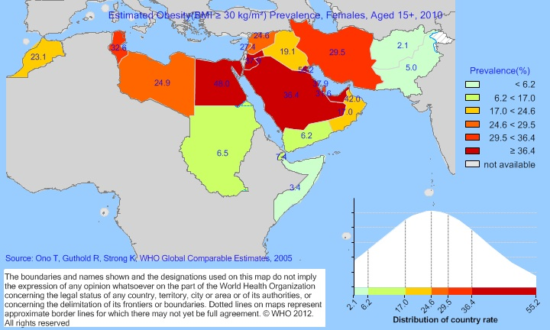

4.1. Organizational Feasibility study
Our software application offers a solution for obesity and overweight by providing diets plans, physical excises and information about benefit of different types of food.
In addition to that, the website will provide some additional features like calculating the ideal weight and some tips about how to keep healthy and fit, this will help users save costs and time wasted in visiting nutrition clinics and also will motivate them in a way much less conventional.
Taking in the consideration that users’ data will not be visible to others in order to guarantee user’s privacy.
4.2. Economic & Technical Feasibility study
This project is going to be developed at a sufficient cost so that it will be acceptable by all the clients that need such type of applications.
Concerning the technical aspect, it is possible to develop the system using current technology and the available tools: PHP, MySQL, Apache, JavaScript, HTML5, CSS3 & some plugins. Also all the traditional fitness website’s functions and fitness apps can be implemented using tools mentioned above.
4.3. Integrality Feasibility study
As we are developing a website, it can be viewed on almost any web browser (except for some browsers that do not support specific needed plugins) and we are intending to make our website responsive so that it can be user-friendly and easily viewed (portable) on so many devices (mobile phones, tablets, etc…). (This issue will be firmly specified in iteration 2)

Requirements Specifications

User Requirements (User Stories)
<The services provided for the user should be described in this section. This section should be understandable by system users who do not have detailed technical knowledge. Each requirement should take a unique identifier as follows. Remember that you will be using these identifiers later on in the design, implementation and even testing phases>

<This should give a brief description for each functional requirement along with the importance priority for each according to the user>

Calculate weight
Identifier: USCW
Description: Users will be allowed to calculate their ideal weight in order to determine how overweighed or underweighted they are and how much weight they need to lose or gain according to user’s age, gender, and height.

Find an exercise
Identifier: USFE
Description: Users will be provided with different types of physical exercises for different body parts, each user will be able to choose which exercise is more suitable for him/her to burn fats of certain body part, and what are the right conditions to practice each exercise as duration, right positions, … etc.

Sign Up
Identifier: SUP
Description: visitor can sign up by entering (name, password, mail, weight, height, gender and age) then he has an account.

Sign In
Identifier: LGN
Description: A Visitor can log in in order to access his/her personal account and keep up with user’s weight progress and have access to some special features with his/her data.

System Requirements (Use Cases)
<The services provided for the user should be described in this section from the system view not a user view. This section would be understandable by the development team. Each requirement should take a unique identifier as follows and map to the user story. Remember that you will be using these identifiers later on in the design, implementation and even testing phases.>

<Show first the use case diagram>

<Use Case Description>

Name: calculate weight

Identifier UCW

Preconditions (List the state(s) the system can be in before this use case starts)

Basic Course (Describe the “normal” processing path, aka, the Happy Path)
- Select calculate weight feature
- Enter gender , height and age
- Submit

Alternate Course A: Description of the alternate course
Condition: if user entered invalid value for age or height
A message will pop up to make him change the values

Post conditions (List the state(s) the system can be in when this use case ends)
- The ideal weight will appear to the user

Map to: calculate weight

Find an exercise
Identifier UCFW

Preconditions (List the state(s) the system can be in before this use case starts)
None

Basic Course (Describe the “normal” processing path, aka, the Happy Path)
- Select physical exercise feature
- Enter body part (optional).
- Submit.

Alternate Course A: Description of the alternate course
None

Post conditions (List the state(s) the system can be in when this use case ends)
- The exercise will appear.

Map to: calculate weight

5.2.3
Name: Sign Up

Identifier USU

Preconditions
- Visitor has an Email
Basic Course
- Click Sign Up button
- Fill the data
- Check data
- Send a verification email
- Check code

Alternate Course A: Description of the alternate course
Condition:
      - Visitor doesn’t have a valid email
  - Appear message enter a valid email.
      - Weight less than 30kg
2.1. Appear message enter a valid weight.
      - Height less than 1m
3.1. Appear message enter a valid Height.
      - Not Fill all data
4.1. Please fill all data
5. Visitor doesn’t write a code
5.1. Appear message check mail if not found please make a new account

Post conditions (List the state(s) the system can be in when this use case ends)
- User has account
- User has Personal profile

Map to: SUP

<Use Case Description>
Name: Sign In

Identifier LOI

Preconditions
1. Visitor has an account
Basic Course
1. Click Login button
2. Fill Username and password
3. Check validation

Alternate Course A: Description of the alternate course
Condition:
- Visitor entered invalid password
  - Appear a message contains incorrect password, please reenter or click forget password.
- Visitor entered a not existing username
  - Appear a message contains incorrect username, please reenter.

Post conditions
- Accessing his profile

Map to: LGN

Non-functional Requirements
< These are the constraints imposed by the user or understandable from the user stories and their business. Each requirement should have a unique identifier that can be used as a reference in other documents.>

<Requirement Description and the user stories ID that this requirement is addressing>

<Requirement Description>

High level plan

<Give a high level plan of the schedule of all iterations you expect the project to undertake in a tabular form as follows.>

Iteration 1:
User Stories | Estimated Time
1.
2.
Total Time

Iteration 2:
User Stories | Estimated Time
1.
2.
Total Time

Table 1: High Level Plan

<Please be reasonable in your time estimation. It does not have to be exact, we are here to learn, and now is a good time to learn some time management. For the software engineering course make each iteration runs for three weeks only. In this course, you will be asked to deliver three iterations only.>

User Stories Time Plan
<You should add here the time plan chart for working on the user stories based on the estimated time table you filled above and the dependability matrix between the user stories listed in appendix B>

Staffing
<You should add here the time plan chart for staffing>

Supporting Information
[The supporting information makes the SRS easier to use. It includes: a) Table of contents, b) Index, c) Appendices. These may include use-case storyboards or user-interface prototypes. When appendices are included, the SRS should explicitly state whether or not the appendices are to be considered part of the requirements.]

Appendix A

Traceability Matrix

RID | US1.1 | US1.2 |  |  |  |  |  |  | ….
UC1.1 |  | 
 |  | 
 |  |  |  | 
NF1.1
NF1.2
… |  |  |  |  |  |  |  |  | 

<This traceability matrix should provide the relationship between the user requirements (user stories) and the system functional (use cases) and non-functional requirements, such that each check mark indicates a relationship between the user requirements with IDs in column and system requirement with IDs in row. So that any change in a user requirement, from this matrix we can find what system requirements that may be affected by this change.>

Appendix B

Dependability Matrix

RID | US1.1 | US1.2 |  |  |  |  |  |  | ….
US1.1 |  | 
US1.2
 |  | 
 |  |  |  | 
… |  |  |  |  |  |  |  |  | 

<This dependability matrix should provide the dependency between requirements, such that each check mark indicates a dependency between the requirements with IDs in column and row. So that any change in a requirement or the design work product done later for a requirement is done, from this matrix we can find other requirements that may be affected by this change.>

